# **Sir Syed University of Engineering & Technology (SSUET)**



# **Computer Engineering Department**

***Course Name: DATABASE MANAGEMENT SYSTEMS (CE-301L)***

***Semester: 5TH***

***Batch: 2021F***

***Section: B***

**PROJECT REPORT**

***Project Title: Website for SPARK BIZ***

|  |  |
| --- | --- |
| **Name** | **Roll Number** |
| **MUHAMMAD KHALIL ASHRAF (GL)** | **2021F-BCE-199** |
| **MUHAMMAD HUZAIFA** | **2021F-BCE-244** |
| **INSHARA AHMED** | **2021F-BCE-065** |
| **RIJA JAVED** | **2021F-BCE-059** |

***Submitted To:***

***Engr. Faiza Farooq***

**TABLE OF CONTENTS**

1. Acknowledgement ……………………………………………… 3

2. Abstract …………………………………………………………. 4

3. Introduction ……………………………………………………... 4

4. Methodology …………………………………………………..... 5

4.1 Database Schema …….............................................................. 5

4.2 ERD (with relational mapping) …………………………….... 6

4.3 Normalization .……………………………………………...... 7

4.4 Theoretical description with definitions ……………………... 9

5. Results …………………………………………………………… 10

6. Conclusion ……………………………………………………..... 13

7. References ………………………………………………………. 14

***ACKNOWLEDGEMENT***

It is an honor for me to express our special gratitude towards Miss Faiza Farooq for her constant efforts, suggestions, guidance, and assistance whenever we needed it the most. She has also been an inspiration for us, encouraging constant hard work towards our goals. Without her, it would have been difficult to complete the project and understand the subject within the given time. We are also thankful to the entire team that worked behind the scenes, especially the Head of the Department of Computer Engineering at Sir Syed University, for making it all possible and granting us permission to continue the project. Given this opportunity, we would also like to express our thanks to all the respective teachers in the department for their efforts and for being a source of inspiration and motivation. They have guided us in the right way to achieve the maximum in life ahead.

## Abstract

This project entails the conception and realization of a responsive website tailored for SPARK BIZ, a dynamic UI/UX company. The multifaceted components of this endeavor encompass meticulous attention to front-end design principles and the seamless integration of a robust database system. The website, meticulously crafted for optimal user experience, facilitates the efficient management of customer orders and incorporates a sophisticated monthly reports generator. The deployment strategy involves hosting the platform on a dedicated domain, ensuring accessibility and functionality for both administrative and end-user perspectives. Through this initiative, the project aims to elevate SPARK BIZ's digital presence, streamline business operations, and enhance the overall user interaction experience.

## Introduction

The introduction sets the stage for an in-depth exploration of the Responsive Website Design initiative undertaken for SPARK BIZ, a prominent UI/UX company. This project involves the development of a user-centric website, prioritizing responsiveness and seamless user experience. The key components include robust front-end design for an intuitive interface, coupled with intricate database connectivity. The database not only stores customer orders but also integrates a sophisticated monthly reports generator, enhancing the company's analytical capabilities. Furthermore, the deployment aspect encompasses the strategic placement of the website on a domain, ensuring accessibility and visibility for a wider audience. This introductory section aims to provide a comprehensive overview of the project's scope, emphasizing its significance in elevating user engagement and optimizing business functionalities.

## 4. Methodology

## 4.1 Database Schema

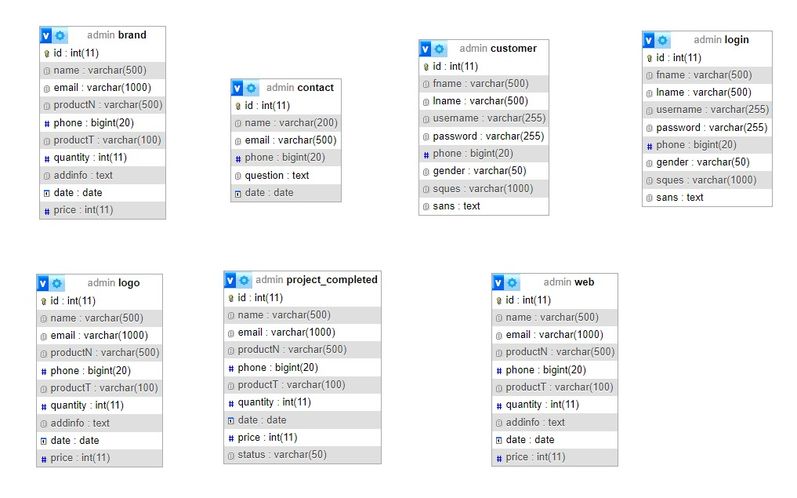

## 4.2 ERD (with relational mapping)

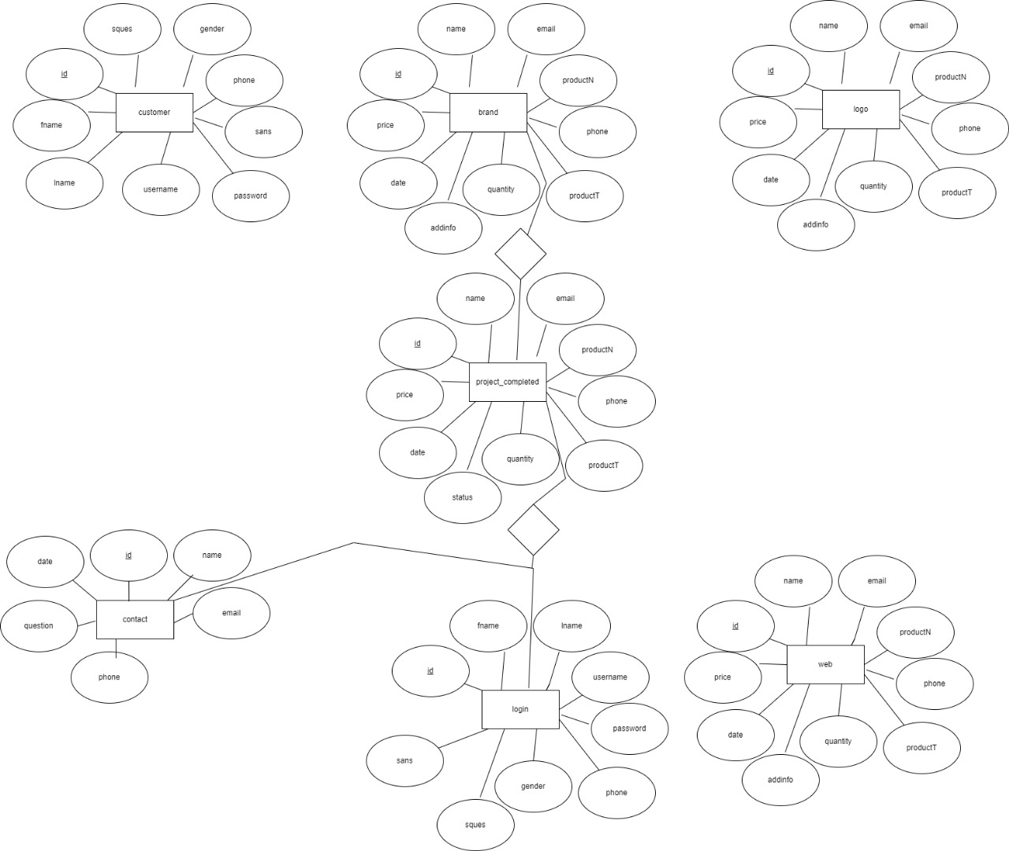

## 4.3 Normalization

Normalization is a database design technique used to organize tables and minimize data redundancy. The normalization process involves dividing large tables into smaller, related tables and defining relationships between them. The goal is to eliminate data anomalies and ensure data integrity.

* **Original Tables:**

**1. customer Table:**

- Attributes: id, fname, lname, username, password, phone, gender, sques, sans

**2. brand Table:**

- Attributes: id, name, email, productN, phone, productT, quantity, addinfo, date, price

**3. logo Table:**

- Attributes: id, name, email, productN, phone, productT, quantity, addinfo, date, price

**4. project_completed Table:**

- Attributes: id, name, email, productN, phone, productT, quantity, date, price, status

**5. contact Table:**

- Attributes: id, name, email, phone, question, date

**6. login Table:**

- Attributes: id, fname, lname, username, password, phone, gender, sques, sans

**7. web Table:**

- Attributes: id, name, email, productN, phone, productT, quantity, addinfo, date, price

* **Normalization Steps:**

**1. First Normal Form (1NF):**

- Ensure that each attribute contains atomic (indivisible) values.

- All tables appear to be in 1NF.

**2. Second Normal Form (2NF):**

- No partial dependencies on a composite primary key.

- Identify and remove partial dependencies.

**3. Third Normal Form (3NF):**

- Eliminate transitive dependencies.

- Identify and remove transitive dependencies.

* **Proposed Tables:**
* **Table: customer**

- Attributes: id (PK), fname, lname, username, password, phone, gender, sques, sans

* **Table: brand**

- Attributes: id (PK), name, email

- Attributes: product_id (PK), brand_id (FK), productN, phone, productT, quantity, addinfo, date, price

* **Table: logo**

- Attributes: id (PK), name, email

- Attributes: product_id (PK), logo_id (FK), productN, phone, productT, quantity, addinfo, date, price

* **Table: project_completed**

- Attributes: id (PK), name, email

- Attributes: project_id (PK), completed_id (FK), productN, phone, productT, quantity, date, price, status

* **Table: contact**

- Attributes: id (PK), name, email, phone, question, date

* **Table: login**

- Attributes: id (PK), fname, lname, username, password, phone, gender, sques, sans

* **Table: web**

- Attributes: id (PK), name, email

- Attributes: product_id (PK), web_id (FK), productN, phone, productT, quantity, addinfo, date, price

## 4.4 Theoretical description with definitions

The theoretical underpinning of the Responsive Website Design initiative for SPARK BIZ revolves around integrating principles from Human-Computer Interaction (HCI), User Experience (UX) design, and Database Management. These theoretical frameworks collectively guide the project to create an online platform that not only meets industry standards but also exceeds user expectations.

* **Human-Computer Interaction (HCI):**

The HCI framework forms the basis for designing a user-friendly interface. It emphasizes the importance of understanding users' behaviors, needs, and preferences in the digital environment. Incorporating HCI principles ensures that the website is intuitively navigable, providing a positive and efficient user experience.

* **User Experience (UX) Design:**

The UX design theory focuses on crafting an experience that goes beyond mere usability. It delves into the emotional and psychological aspects of user interaction. By adopting UX principles, the project seeks to create a website that not only functions seamlessly but also evokes a positive emotional response, fostering user satisfaction and loyalty.

* **Database Management:**

The database management theory plays a crucial role in shaping the back-end architecture of the website. It guides the implementation of a robust database system for storing and managing customer orders. This ensures data integrity, security, and efficient retrieval, contributing to the overall reliability of the platform.

* **Systems Theory:**

A systemic approach, drawing from Systems Theory, is employed to understand the interconnected components of the website. This theory aids in comprehending the relationships between the front-end design, database management, and overall system functionality. The goal is to create a holistic digital ecosystem that functions synergistically.

* **Information Architecture:**

Information Architecture principles guide the organization and structuring of information within the website. This theory is vital in creating a clear and logical pathway for users, enhancing their ability to navigate and locate information effortlessly. Effective information architecture contributes to the overall coherence and usability of the platform.

* **Technology Acceptance Model (TAM):**

TAM is considered to understand and predict user acceptance of technology. By incorporating TAM principles, the project aims to create a website that aligns with users' perceived usefulness and ease of use, increasing the likelihood of widespread acceptance and adoption.

In summary, the theoretical framework of this project is a nuanced blend of HCI, UX design, Database Management, Systems Theory, Information Architecture, and TAM. This eclectic approach ensures a comprehensive and thoughtful development process, aligning the website with both industry standards and user expectations. Through the application of these theories, the project aspires to not only elevate SPARK BIZ's digital presence but also establish a benchmark in the realm of responsive website design and user-centric technology solutions.

## 5. Results

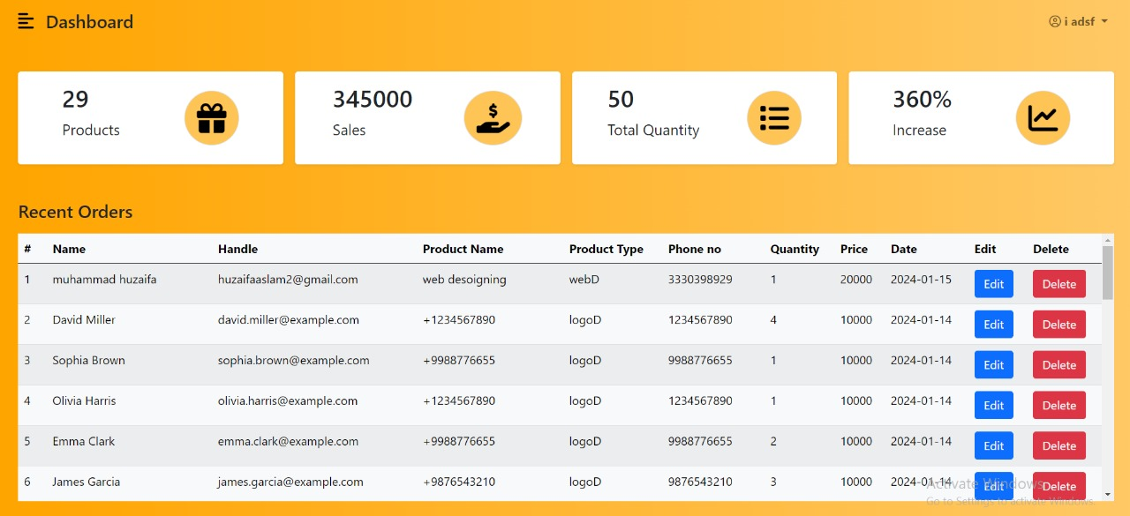

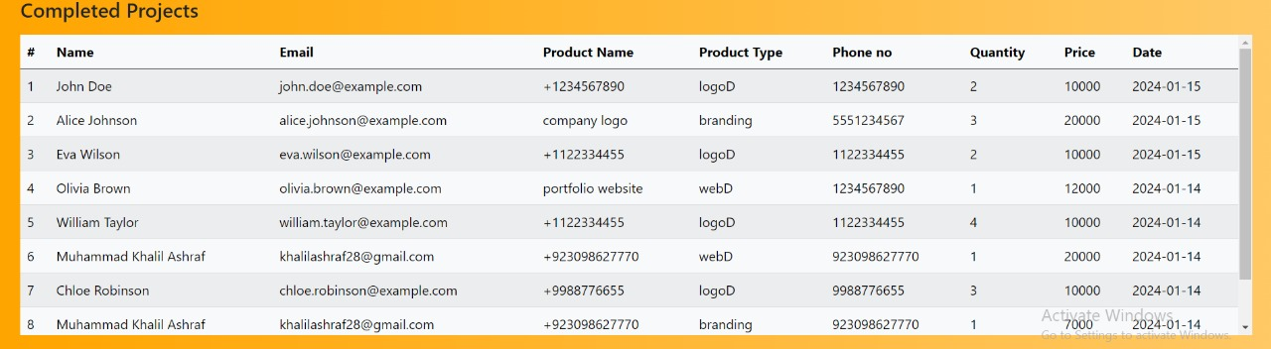

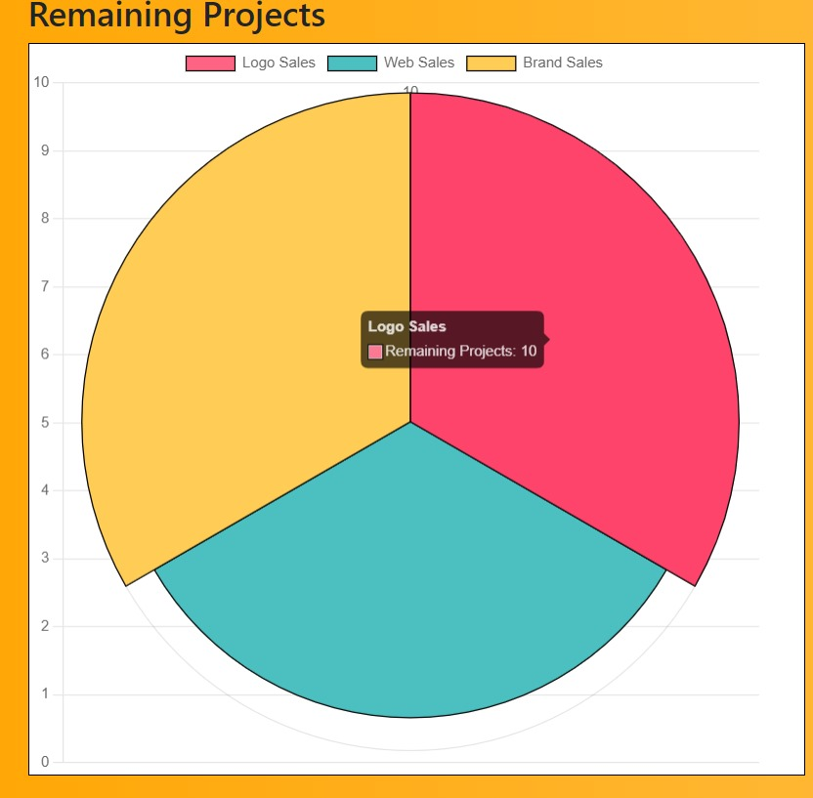



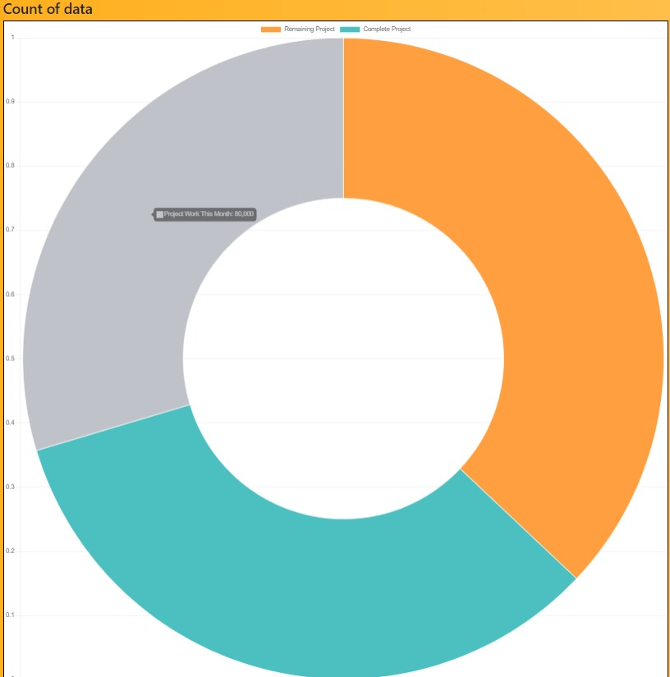

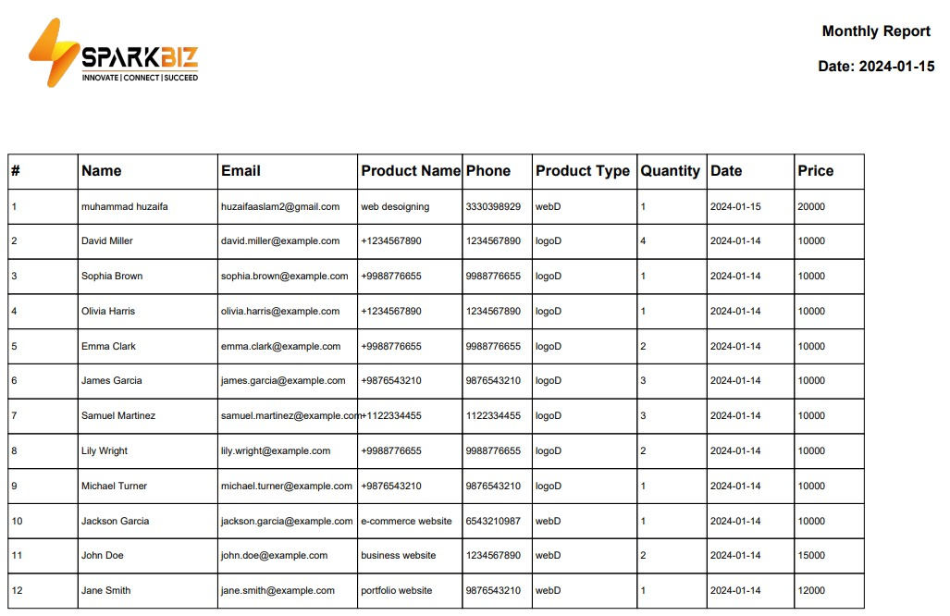

## 6. Conclusion

In conclusion, the Responsive Website Design project for SPARK BIZ has successfully brought theoretical concepts into practical fruition. By integrating principles from Human-Computer Interaction, User Experience design, Database Management, Systems Theory, Information Architecture, and the Technology Acceptance Model, we've created a user-friendly, reliable, and engaging digital platform.

The careful application of these theories ensured that our website not only meets industry standards but exceeds user expectations. The result is a responsive, intuitive interface that fosters positive user experiences. The robust database system guarantees the security and efficiency of customer order data, enhancing the overall reliability of the platform.

With the website's deployment on a dedicated domain, we've ensured accessibility for both administrators and end-users, thereby elevating SPARK BIZ's digital presence. This project demonstrates the tangible impact of theoretical frameworks on real-world applications, setting the stage for enhanced user engagement and streamlined business operations.

## 7. References

* Fundamentals of Database Systems by Ramez Elmasri (Author), Shamkant Navathe (Author), Addison Wesley, 7th Kindle Edition. ISBN-13: 9780137502523. Published by Pearson (July 14, 2021) © 2016.

[**https://amirsmvt.github.io/Database/Static_files/Fundamental_of_Database_Systems.pdf**](https://amirsmvt.github.io/Database/Static_files/Fundamental_of_Database_Systems.pdf)

* Database System Concepts, 7th Edition by Abraham Silberschatz and Henry Korth and S. Sudarshan,ISBN10: 0078022150, ISBN13: 9780078022159, Published: February, 2019